*Project:*

**Project Working Title:** Ranking of radio signals in search of signals from pulsars

**Project End Date**: 7 May 2021 (The end of week 6 of spring term)

*Student:*

**Name**: Jaden Downing

**Affiliation:** Department of Physics, Oregon State University

*Statement*: I will work regularly and diligently on this project throughout the year and initiate meetings with my advisor to seek feedback and guidance on the research. I understand that a significant portion of the research should be completed by the end of winter term to enable me focus on the writing process in the PH403 class.

Student Signature: _____________________________

*Advisor:*

**Name** Xavier Siemens

**Affiliation** Department of Physics, Oregon State University

I have read this thesis proposal. I agree that the scope is reasonable for completion by May 7, 2021 and that sufficient progress can be made by early winter term 2021 to allow significant revision of the thesis during the winter and spring terms of 2021.

Advisor Signature*:* _____________________________

**Project Summary**

North American Nanohertz Observatory for Gravitational Waves (NANOGrav) is using signals from millisecond pulsars in order to model gravitational waves. NANOGrav is consistently compiling a collection of periodic radio signals from various sources which have the characteristics of a potential radio signal from a millisecond pulsar. I will search through the compiled signals and rate them on their likelihood of being a signal from a pulsar, from radio frequency interference, or no identifiable signal. I will do this by looking at a profile of the signal which includes its periodicity and length, its dispersion measure, and other characteristics. Upon finding signals that appear to be from pulsars, I will search several databases of known pulsars to determine whether the pulsar has already been discovered. If a new pulsar is discovered, it will be followed up using the Green Bank Observatory (GBO) telescope for timing in gravitational wave research.

**Project Description**

*Introduction*

The North American Nanohertz Observatory for Gravitational Waves (NANOGrav) uses pulsar timing methods to detect and study gravitational waves. Pulsars are rotating neutron stars which rotate at frequencies ranging from fractions of hertz to hundreds of hertz, and emit electromagnetic radiation out of their magnetic poles. [1] These electromagnetic beams may be detected as radio signals only as they point toward the Earth. If a pulsar rotates on an axis other than its magnetic axis, and emits a radio beam that passes periodically over Earth, the radio “pulses” from these pulsars arrive with a frequency comparable in precision to the most precise clocks on Earth. [2]

NANOGrav monitors a consistently growing array of high frequency “millisecond” pulsars across the sky to research gravitational waves. Telescopes on Earth are used to consistently time millisecond pulsars across the sky and look for inconsistencies in the frequency at which radio pulses are detected. As a gravitational wave passes between the Earth and a pulsar, the wave causes a time dilation in the space between the two, resulting in an inconsistency of the frequency of radio pulses measured from Earth. [3] By timing an array of pulsars across the sky, the NANOGrav team hopes to compile findings across decades in order to model a stochastic background, or the collective background of gravitational waves from various sources coming together. [4] Figure 1 illustrates an array of several pulsars surrounding Earth, and includes visuals of the pulsing radio signals we receive on Earth. Recently, the NANOGrav team at Oregon State University has been analyzing the last fifteen years of pulsar timing data to create a stochastic background simulation with the data we have so far.

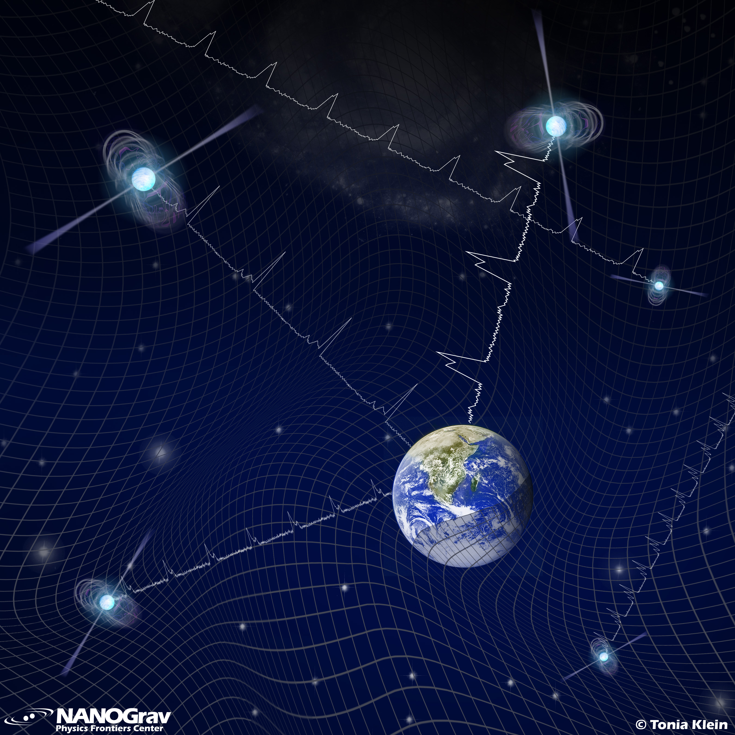

**Figure 1.** A visualization of the network of radio signals received on Earth from various pulsars. Although not visible in reality, the frequencies of the various radio pulses are included in this image, as well as the fabric of space time. As space time, shown in this rendition as a warped grid, is dilated or misshapen, the distance across which the radio pulses travel to reach Earth is shortened or lengthened, resulting in a change of frequency.

In order to continuously improve the accuracy of NANOGrav’s models and further understand gravitational waves, the team is consistently searching for previously unknown pulsars to time. By timing pulsars of various directions and distances from Earth, the stochastic background may be more thoroughly modeled. As such, my work on the project includes analyzing thousands of radio signals detected by the Green Bank Telescope and determining which signals are likely to be radio signals generated by a pulsar as opposed to radio interference on Earth. In order to do this, I consider various characteristics of the signal, including its frequency, dispersion measure, and phase plot.

-*Include an introduction to what dispersion measure, etc are here?*

*Plan of work*

Pulse profiles of thousands of new radio signals recorded by the Green Bank Observatory (GBO) telescope are consistently uploaded to a shared website, CyberSKA. I analyze pulse profiles on CyberSKA one by one, and rate each signal on its probability of being radio frequency interference, a known pulsar, or an unknown pulsar of class 1, 2, or 3, with class 1 being an extremely probable pulsar. Candidates rated as likely pulsars may then be followed up with the GBO telescope later in order to be confirmed as pulsars and begin timing. Figure 2 shows an example profile from CyberSKA, in this case rated class 3.

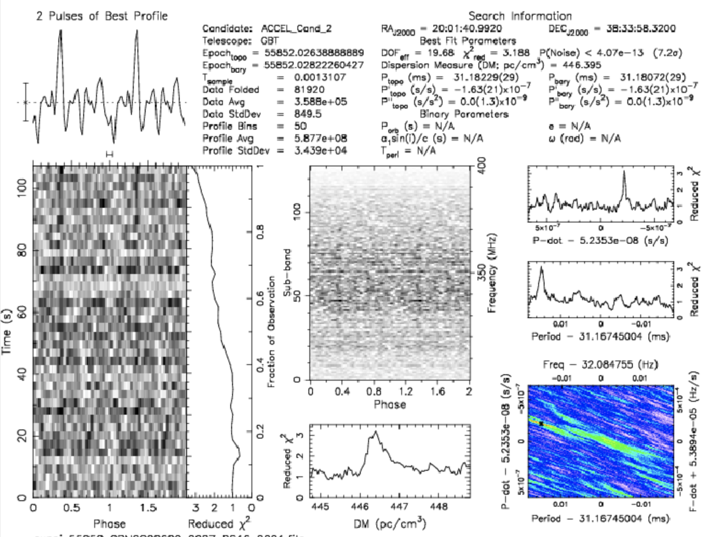

**Figure 2.** A class 3 potential pulsar candidate found on CyberSKA.

-*Include discussion of the individual components I will use for ranking: DM, prepfold sigma, bandwidth, etc.*

Upon identifying a candidate that is likely to be a pulsar, I refer to three “scrapers,” or shared databases of known pulsars that NANOGrav (or another international organization) has already identified. On these websites, I use the pulse profile of the signal to see if a pulsar of a similar location, frequency, and dispersion measure has already been identified. If it has, the candidate is ranked as a known pulsar. If not, the candidate is ranked as a class 1, 2, or 3 pulsar and may also be uploaded to a shared slack channel of other NANOGrav team members across the country for review.

By the time the project is complete, I intend to have ranked approximately 3,000 candidates, and ideally to have analyzed at least one promising class 1 pulsar. However, if I do not rank a class 1 candidate myself, I will still have the experience needed to write of my work, and ma collaborate with other Oregon State undergraduate students who have identified class 1 candidates. As of now, I have ranked (?) candidates, and am reading academic papers published by NANOGrav and other organizations for gravitational wave research in order to develop the foundation of knowledge that is necessary to write about my research with precision and detail.

*Timeline*

Research and pulsar candidate ranking began in the Winter of 2019, and will continue throughout the Winter of 2021. I have currently ranked (?) candidates, and by the end of the process I will have ranked about 3,000. By week 6 of Winter 2021 I will have completed the literature review necessary to clearly describe the background and methods of the research. By the beginning of Winter 2021, a skeleton outline of the thesis will be completed. By the beginning of Spring 2021, I will have a completed draft of the thesis, to be polished and modified by week 5 of Spring 2021. Finally, the thesis will be presented in a thesis defense before June of 2021.

*Data management*

Throughout the process of rating candidates, interesting or promising candidates will be screenshotted and saved to a file on my computer dedicated to the thesis process. This file, which will include my drafts of the thesis and thesis proposal, will be backed up regularly to multiple devices, including a USB flash drive. Known pulsars and unranked pulse profiles are uploaded by NANOGrav team members to CyberSKA and various scrapers. The CyberSKA candidates are viewable to all NANOGrav members and others who have been granted access, and the scrapers are public information found on the web.

*Facilities, Equipment and Other Resources*

All information that needs to be utilized for candidate ranking and identifying may be accessed through my personal computer. Collaborators at Oregon State University and other NANOGrav facilities will be consulted consistently to improve the accuracy with which I rate candidates. On a broader scale, the NANOGrav requires access to the Green Bank Observatory telescope in order to continuously time known pulsars and identify new ones. Many NANOGrav members, including graduate students on the team at Oregon State University, utilize Jupyter Notebook in order to analyze data collected at GBO, and create models and simulations.

**References Cited**

[1] S. Shore, “Encyclopedia of Physical Science and Technology”, Third ed., 419-429, (2003).

[2] P. Brady and J. Creighton, “Encyclopedia of Physical Science and Technology,” Third ed., 33-48, (2003).

[3] G. Gonzalez and J. Pullin, “Encyclopedia of Mathematical Physics”, 582-586, (2006).

[4] N. Gorkavyi, “Gravitational wave background discovered by NANOGrav as evidence of a cyclic universe”, New Astronomy, Volume 91 (2022).

Curriculum Vitae

Jaden Downing | Department of Physics, Oregon state University

**Skills Summary**

Basic coding in Python and Mathematica, completion of courses in general physics, differential, integral, and vector calculus, applied differential equations, linear algebra, matrices and power series, general chemistry with lab, electronics, theoretical mechanics, static fields, quantum fundamentals, oscillations and waves, periodic systems, central forces, computer interfacing, and computational physics lab. Works well in groups and in management.

**Work Experience**

**Oregon State University,** Research Assistant / 2020-Present

*Description:* Assisting in research for NANOGrav including identifying and rating pulsar candidates from an online database, supervising telescopes, data analysis, and attending or presenting at research meetings. Participating as a SPOT presenter to present on NANOGrav’s research at local elementary, middle, and high schools.

**Wild Fin American Grill**, Lead Hostess / 2020-2021, Cashier and Cook / 2019

*Lead Hostess:* Coordinating seating, wait lists, and reservations with customers at Wild Fin, Point Ruston waterway. Organizing collaboration between assistant hostesses and other restaurant staff. Taking phone calls, processing to go orders, and sanitizing.

*Cashier and Cook:* Full service including taking food orders, cashier, cooking, prep cooking, and cleaning at Wild Fin outdoor fish bar, Point Ruston waterway

**Rebels and Lovers,** Sales Associate / 2018

*Employer:* Monica Kitchen (206)484-8622 |monica@rebelsnlovers.com

*Description:* Greeting and assisting customers, working register, merchandising and organizing store, cleaning

**Volunteer Experience**

* Outreach Chair and event volunteer for “Physicists for Inclusion in Science,” Oregon State University (2018-2020)
* Tutoring (2014-2019*)*

**Professional Affiliations**

**Physicists for Inclusion in Science, Oregon State University**

*Positions:* Outreach chair (2019-2020), event volunteer (2018-2020)

*Description:* Planning outreach events to reach elementary and middle school aged students, choosing and building physics related models and games, coordinating and training volunteers, working closely with advisors, teachers, venue operators and event coordinators

**Awards and Recognitions**

**Hundere Excellence in Writing Award, 2019**

**Kenneth S. Krane Scholarship**

**Education**

**B.S. Physics, Oregon State University Honors College, expected 2021**

**B.S. Religious Studies, Oregon State University Honors College, expected 2021**